Grafana/Prometheus/Node Exporter

Launched EC2 instance.

- Node Exporter Setup
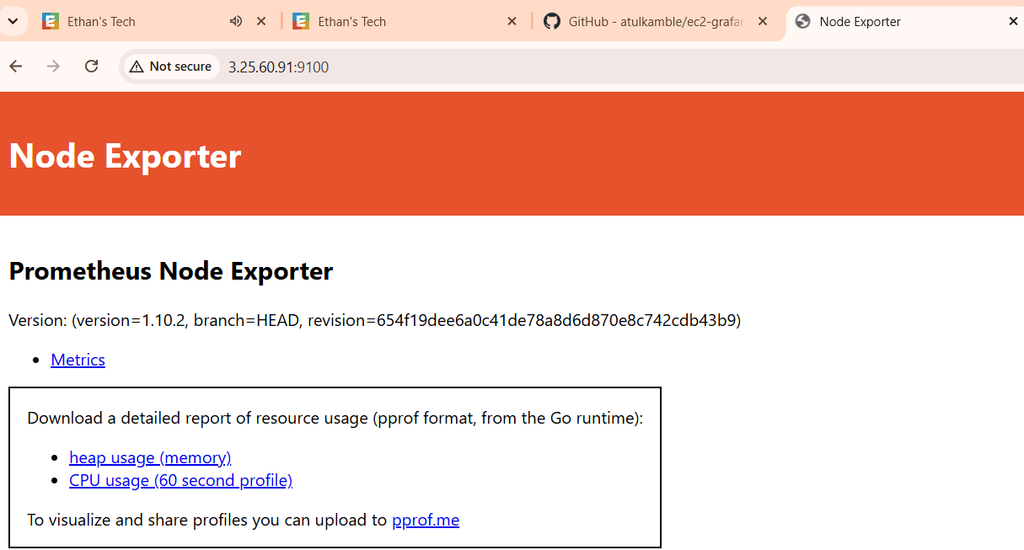

- Grafana Setup

Password – admin@123

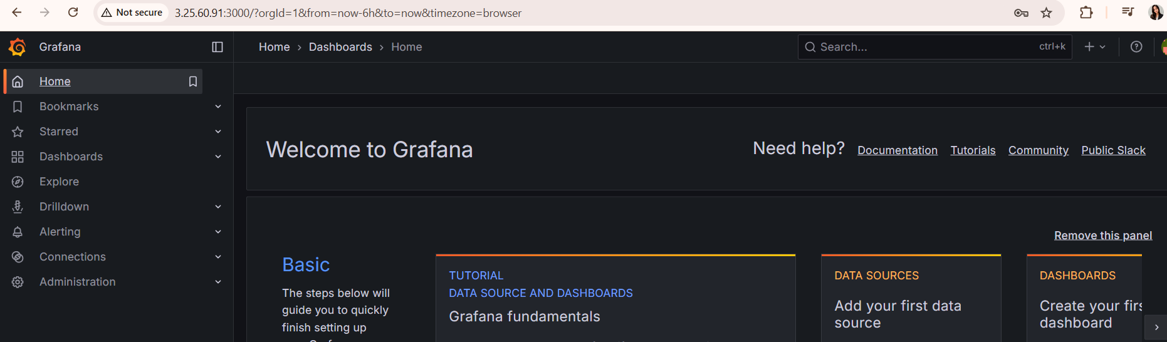

- Prometheus

scp -i grafana.pem \
prometheus-3.5.4.linux-amd64.tar \
ec2-user@ec2-3-25-60-91.ap-southeast-2.compute.amazonaws.com:/home/ec2-user/
Password - Pookie@#45

sudo mv prometheus-3.5.4.linux-amd64.tar.gz/opt
cd /opt
sudo tar -xvf prometheus-3.5.4.linux-amd64.tar.gz
sudo mv prometheus-3.5.4.linux-amd64 prometheus
sudo rm prometheus-3.5.4.linux-amd64.tar.gz

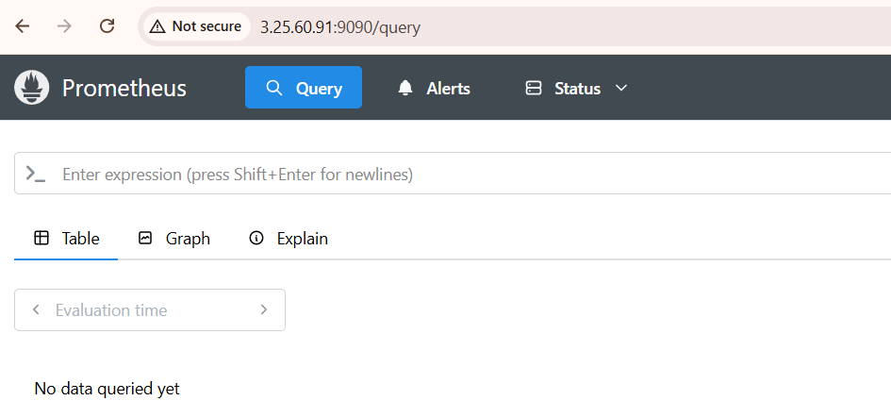

Assigned required permission to node_exporter

